Chapter 5, Solution 68.

If R_{q} = ∞, the first stage is an inverter.

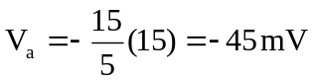

when V_{a} is the output of the first op amp.

The second stage is a noninverting amplifier.

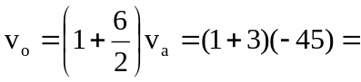–180mV.

